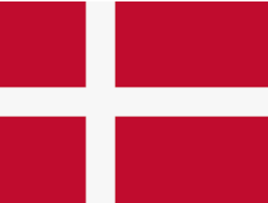Denmark – The Land of Islands

**The sea, beaches and islands are part of the Danish landscape.** Denmark is the most southern Nordic country. Denmark is the smallest of the Nordic countries but has a lot of people for a country its size, about 5.6 million. The population is the densest in the Nordic countries.

**The capital city Copenhagen is the biggest city in Denmark.** Other important cities are Århus, Odense and Ålborg. Denmark is one of the oldest countries in Europe. The country is a constitutional monarchy and the queen of Denmark, Margarethe II Denmark, has been the queen since 1972. The Danish parliament is called Folktinget and the currency is called the Danish krone.

**A Peninsula and Hundreds of Islands**

Denmark is made up of the Jutland peninsula and over 400 islands. The biggest islands are Själland, Fyn and Lolland. These islands are connected by bridges. The Faroe Islands and Greenland far out in the Atlantic also belong to Denmark.

Denmark shares a land border with Germany and sea border with Sweden and Norway. The country is also surrounded the North Sea and the Baltic Sea.

**Moulding Nature**

**As Denmark is densely populated, it has little of its original nature left.** Most of the forests have been cut down to make way for houses and fields. However, forests have been replanted. Denmark is mostly lowland with winds blowing from the Atlantic Ocean. **The maritime climate in Denmark is mild and the growing season is long.** The land is also even and the soil rich, which makes Denmark a good area for farming. The agriculture (farming) in Denmark is productive and effective.

Denmark is also known for its dunes on its west coast. These are sandy, treeless hills which move inland from the shore, little by little, driven by the wind. Pines and grasses have been planted on the dunes, because their roots bind the sand. This has been done to stop the dunes from moving.

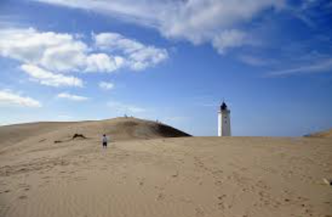

Copenhagen is the capital city. Sand dunes on the west coast.